Coaches Access to print Game Cards/Enter Scores for Area Games
- Login to your regional website.
- Click on their volunteer tab which will bring up the below screen.
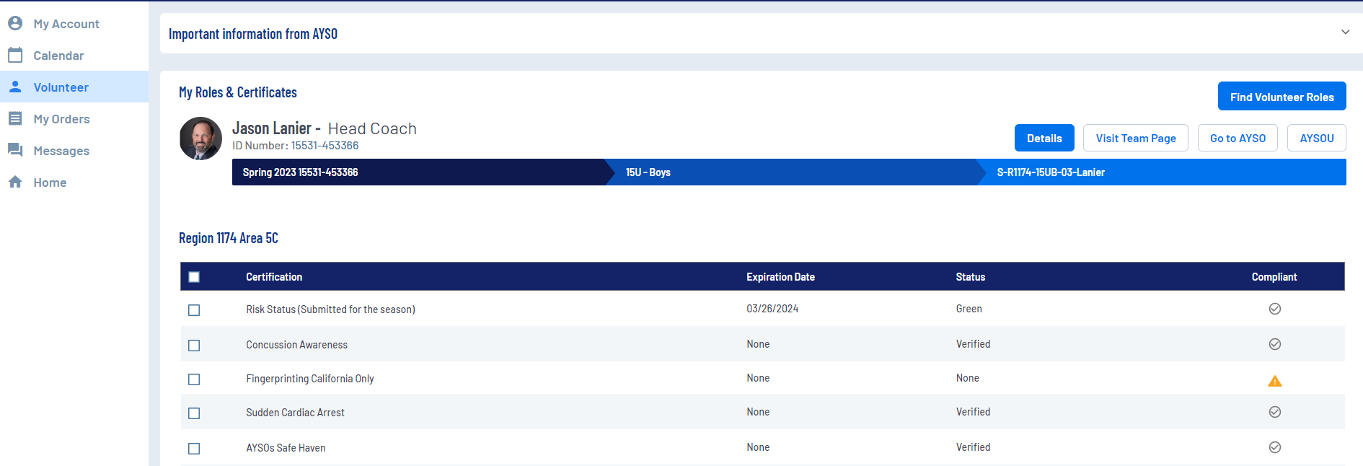
- On this screen to the right of the Coaches name will be 4 buttons. Details, Visit Team Page, Go to AYSO, AYSOU.
  - Coaches can print lineup cards in one of two places dependent on how your region wants to collect them or they can use pre-made lineup cards where they have to write in team roster. This depends on how you want to collect them.
    - Visit Team Page takes them to the Team Page on your website(Team has to be posted for this page to show for them). Once on team page, Click the Roster tab and this page will show.
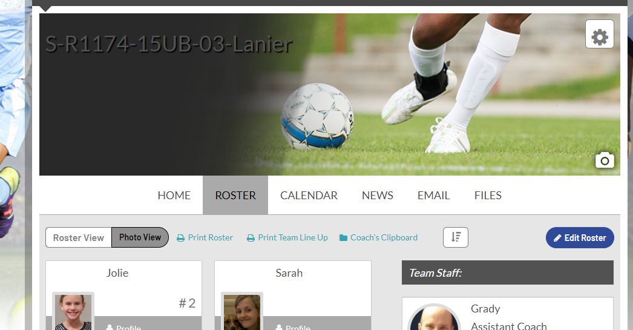
    - Hit the Print LineUp card button to print a lineup card with your roster pre-populated. This will print 4 lineup cards per page that can be used through the season.
  - The second method prints a unique lineup card for each game. Go back to the screen in Step 2. Now hit the Go to AYSO button. This will pull up the coaches’ profile in the association platform and the screen will look like below.

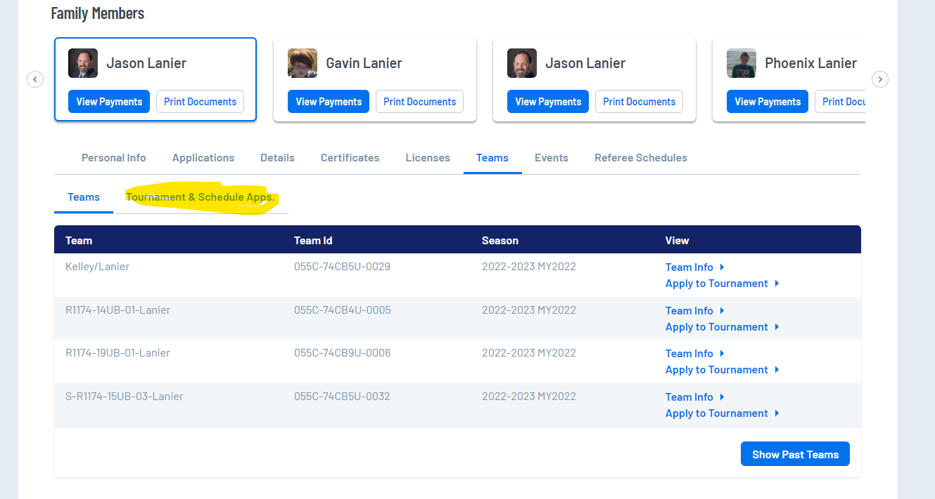
    - On this screen, above the list of teams will list Teams and Tournament & Schedule Apps. Click the Tournament & Schedule Apps tab (highlighted above)
    - The following screen will look like below. On this screen they will choose schedules and Game Scoring.
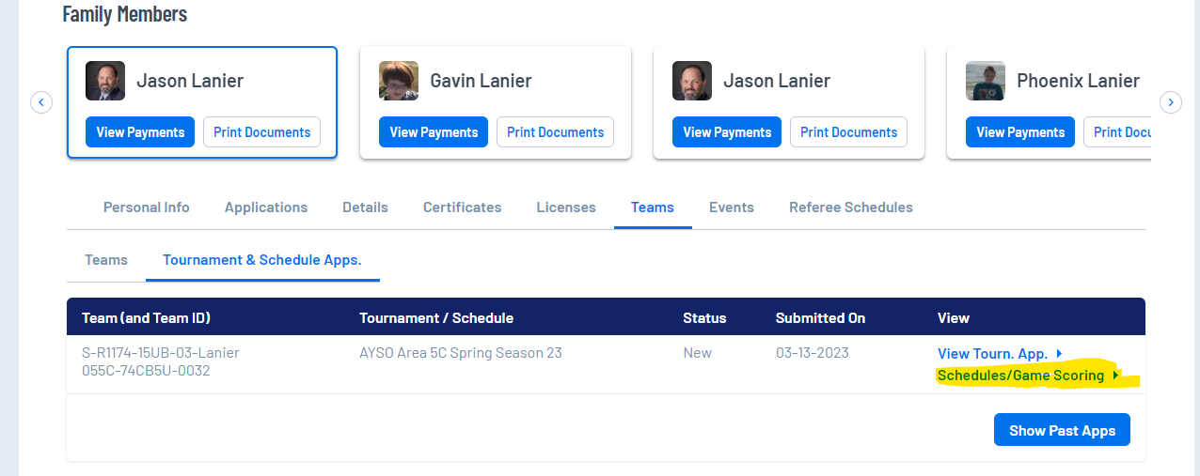
    - That will then bring up a unique schedule for the coach where they have the ability to print the game card for the game they are playing. Near the bottom of the screen for each game will be a print roster button that shows about 2 weeks before the game** Note that opponents that are not currently AYSO will not have a roster that shows. **
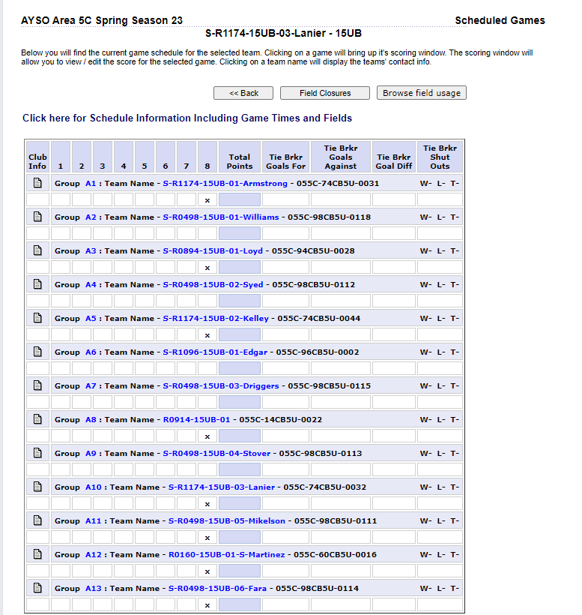
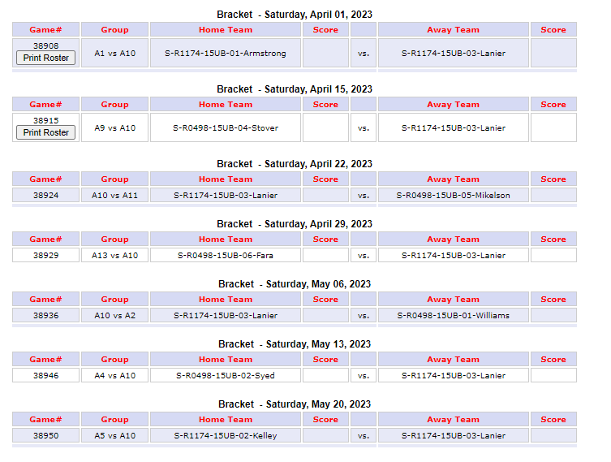
- Entering Game Scores after the game. We have a 3 part method for ensuring accurate game scores. Each coach(unless non-AYSO team) would enter the score and the referee will score on the referee site. If coaches score matches it gets entered officially, if discrepancy then the referee score is used as the final. The scoring window also lets you track your player goals as well for stat keeping. Yellow and Red cards are tracked as well and a red card results in 1 game additional suspension dependent on regional review.
  - To enter scores follow all of the steps in 3b to get back to the same screen you printed game cards on. On this screen click on the score for your team box and it will bring up a scoring window that looks like the screen below
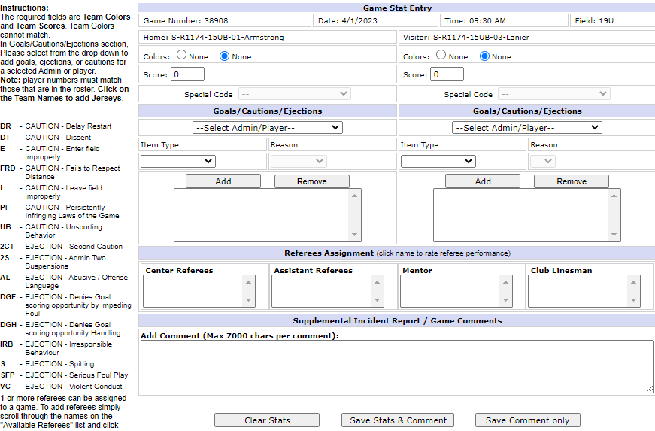
  - Scoring
    - Enter scores for the team in the score box
    - Special code is used for forfeits and will be marked by Area if needed
    - To enter player goals and/or cards Select the Player/coach name from the dropdown list, Select Goal, Yellow, Red, Suspected concussion, etc from the Item Type and if a card you choose the reason code as displayed to the left. Then hit Add.
    - Once all of your edits are in then choose Save stats and comment at the bottom

